**IL1105: Design Thinking**

**ASSIGNMENT 2**

**Identifying the Persona of People**

Section: A

**SUBMITTED BY:**

Aastha Gupta (2022Btech002)

Chaitanya Agarwal (2022Btech026)

Riya Singh (2022Btech088)

Siddhi Nyati (2022Btech101)

**FACULTY GUIDE:**

Mr. Dhruv Saxena

JK Lakshmipat University

Institute of Engineering & Technology

**Ethnographic:**

It involves the in-depth study of people and cultures in their natural environment. The goal is to understand the social practices, rituals, and daily life of a group by immersing oneself in their culture. Ethnographic studies typically focus on understanding the "why" and "how" of people's behaviors, cultural practices, beliefs, and social interactions.

**Demographic:**

Demography is the statistical study of human populations. It deals with the quantifiable characteristics of a population, such as age, gender, income, education, employment, birth rates, death rates, and migration patterns. Demographic data helps in understanding the "what" of a population. It is often used to identify trends and patterns within a population.

**Ethnographic and Demographic Study of University Staff**

In today’s assignment, we interviewed three staff members of our university and gathered ethnographic and demographic information about each of them. This exercise aimed to create fictional personas based on their responses.

**INTERVIEW 1**

1. **Demographic Persona**

* Full Name: Vaibhav (Topiwala Sir)
* Gender: Male
* Age: 26
* Height: 5’11”
* Mother Language: Gujarati
* Languages Known: Hindi, English
* Nationality: Indian
* Educational Level: Postgraduate in Law (Advocate)
* Occupation: Not specified
* Income Level: Middle class
* Location: Haryana (originally from Navsari, Gujarat)
* Family Size: Joint family (10 members)

1. **Ethnographic Persona**

* Religion: Hindu
* Caste: Not specified
* Dietary Preferences: Both vegetarian and non-vegetarian
* Cultural Fest: Loves Dandiya
* Favorite Food: Dhokla
* Preferred Attire: Tracksuits and comfort wear
* Personal Traits: Multicultural, multi-talented, enjoys travelling
* Hobbies: Traveling, playing cricket, and participating in various sports
* Personality: Beard person, enjoys diverse cultural activities

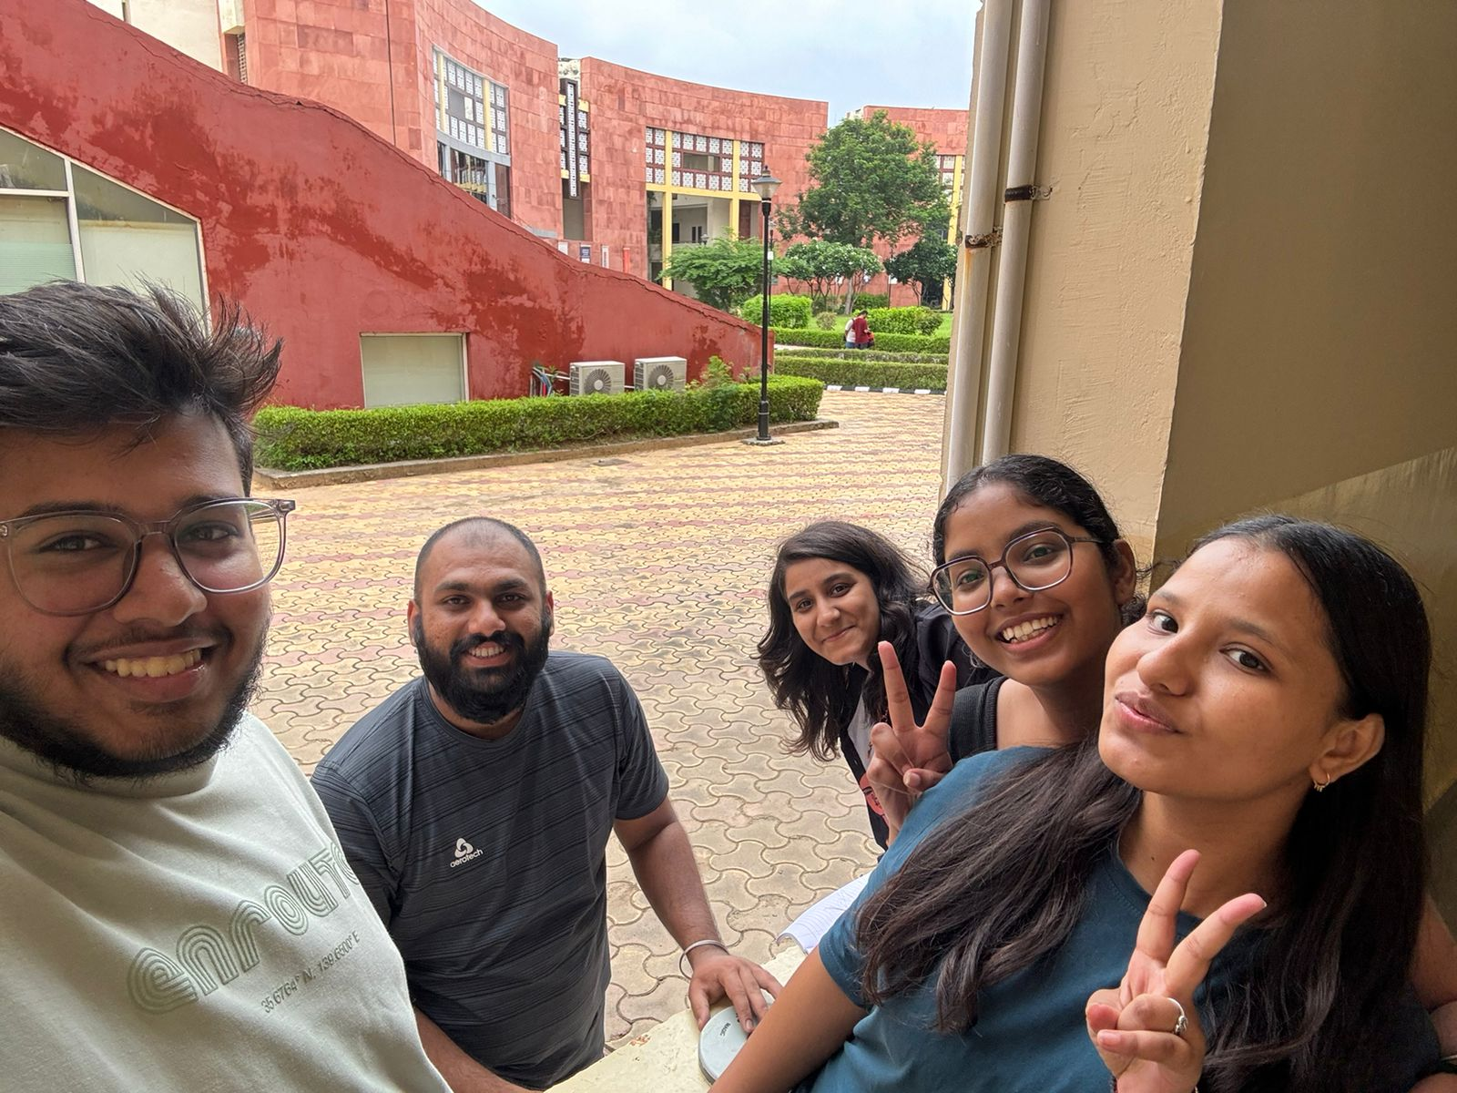

**INTERVIEW 2**

1. **Demographic Persona**

* Full Name: Deepak Sogani
* Gender: Male
* Age: 56
* Height: 181 cm
* Mother Language: Hindi
* Languages Known: Hindi, Marwari
* Nationality: Indian
* Educational Level: Bachelor of Pharmacy
* Occupation: Education professional
* Income Level: Not specified
* Location: Kishangarh, Ajmer
* Family Size: Nuclear family (2 members)

1. **Ethnographic Persona**

* Religion: Jain
* Caste: Not specified
* Dietary Preferences: Pure vegetarian
* Favorite Food: Mirchi Vada
* Cultural Fest: Raksha Bandhan
* Preferred Attire: Simple and attractive clothing
* Personal Traits: Punctual, transparent, flexible, family-oriented, spiritual but not extreme
* Hobbies: Collecting ties (has 76), cricket
* Personality: Values transparency and flexibility, has a deep belief in God but is not extremely religious.

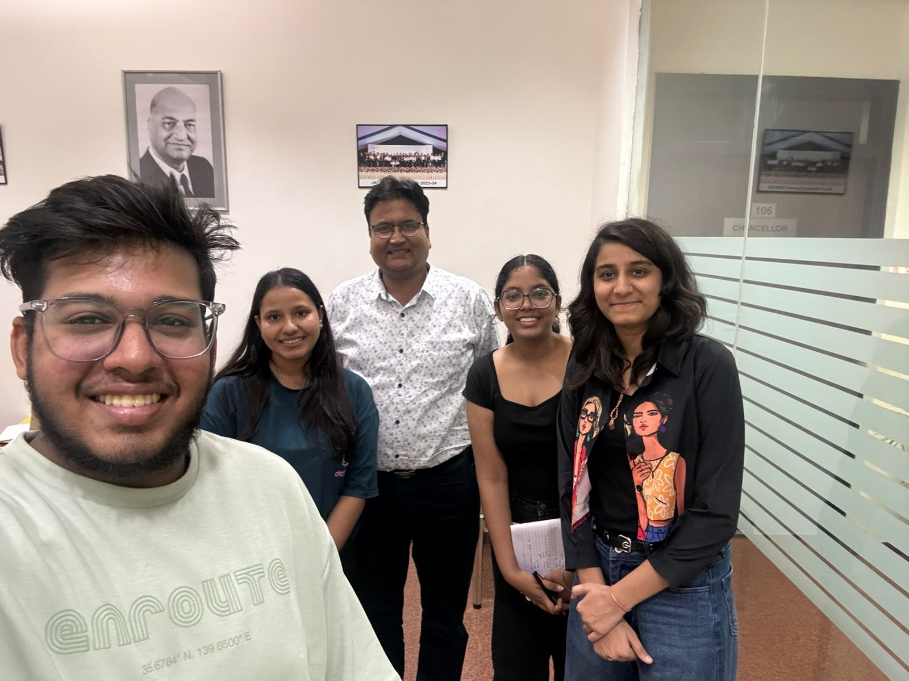

**INTERVIEW 3**

1. **Demographic Persona**

* Full Name: Paritosh
* Gender: Male
* Age: 25
* Height: 5’8”
* Mother Language: Hindi
* Languages Known: Hindi
* Nationality: Indian
* Educational Level: Master’s in Commerce
* Occupation: Service professional
* Income Level: Middle class
* Location: Bihar
* Family Size: Nuclear family (4 members)

1. **Ethnographic Persona**

* Religion: Hindu
* Caste: Kayas
* Dietary Preferences: Non-vegetarian
* Favorite Food: Chicken Tikka
* Cultural Fest: Chhath Puja
* Preferred Attire: Kurta (traditional wear)
* Personal Traits: Patient, good listener
* Hobbies: Playing guitar, singing, badminton
* Personality: Aspires to build a business, enjoys cultural activities and music

